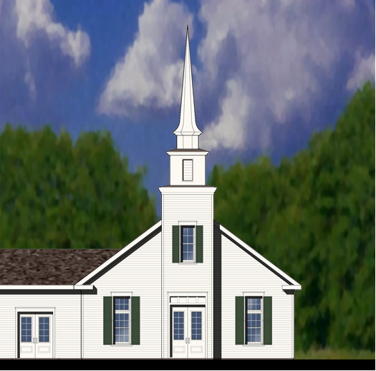
Yaphank Presbyterian Church
65 Main Street, Yaphank, New York 11980
631-775-9495
Yaphank is a “Matthew 25” Church of the PC(USA)
yaphankpresbyterianchurch.org
Glorya J. Johnson, Pastor 516-457-3643
Paul Story, Director of Music and Clerk of Session 631-901-3162
Marjorie Nicodemus, Organist
Yaphank Presbyterian Church
November 8, 2020-9:00 a.m.
23rd Sunday After Pentecost- Veterans Day

SILENT MEDITATION Choices have consequences. Choosing to share the wisdom of God’s holy mystery with the next generation provides our children a chance at a real future.
PRELUDE
GREETINGS/ANNOUNCEMENTS

THE GATHERING

*CALL TO WORSHIP Josh 24, Ps 78, 1 Thess 4
Our ancestors have led us here.
We are witnesses of their faith.
The wisdom of the ages has called us here.
We are children of its call.
The choice to follow God lies before us.
We are heirs of its promise.
The Lord of life has called us here.
We are here to worship the Lord.

*PRAYER OF ADORATION
*HYMN Rejoice, the Lord Is King #363
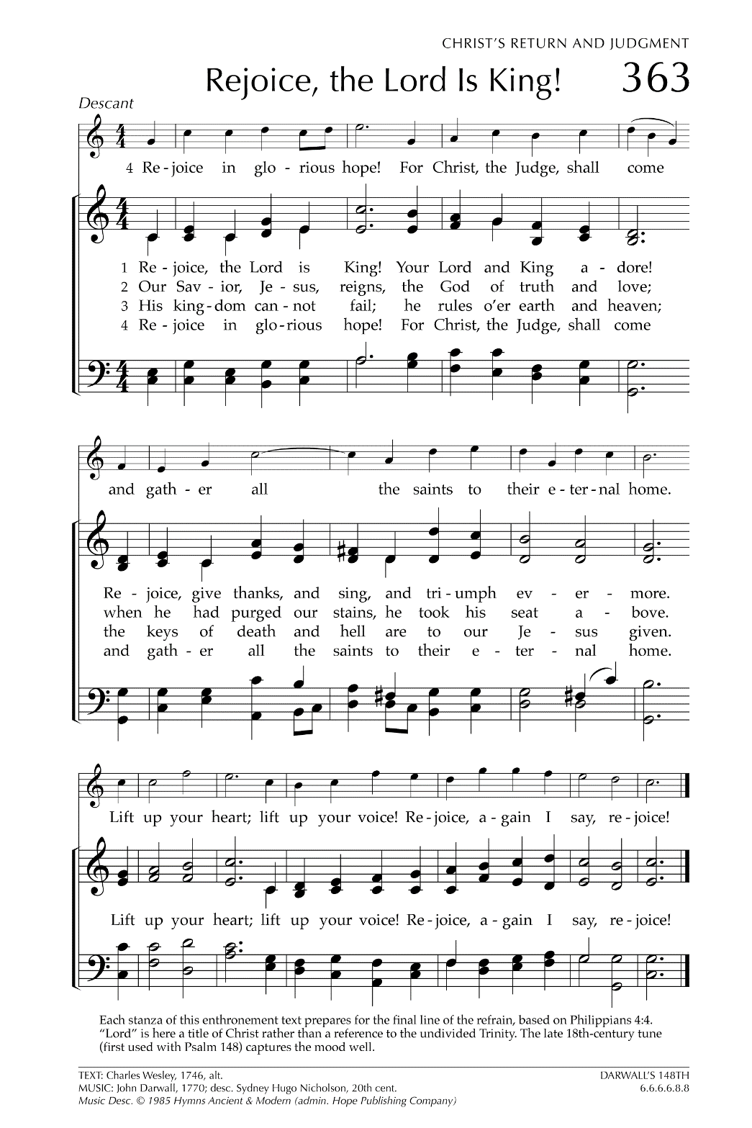

CALL TO CONFESSION In the midst of our daily lives, Jesus Christ calls us to follow him.
Before we continue on the path with Jesus, we must first confess what we lack for the journey, in recognition of the power of sin in our lives.

PRAYER OF CONFESSION Josh 24, Matt 25
We long to have the courage to choose you, O God, each and every day. We yearn for the forbearance to wait patiently, through the long watches of the night—for we long to be found ready, when you appear in your glory. Fill our lamps with your grace, that we might share your light with our children and with the generations to come. (…..silent confession) Amen. Amen

ASSURANCE OF PARDON 1 Thess 4:17 NRSV
Hold onto these words of hope: “We will be with the Lord forever.”
We will love the Lord of life and live.

*GLORIA PATRI #581

*PASSING OF THE PEACE Josh 24, Matt 25
Christ offers us peace when we choose life and follow God.
Let us celebrate this peace as we share signs of God’s blessings and healing wisdom, each and every day.
Hymn of Peace #623 (v1) I’ve Got Peace Like a River
PASTORAL PRAYER
LORDS PRAYER
CHILDREN’S MESSAGE June Newill
*HYMN I’m Gonna Live So God Can Use Me # 700
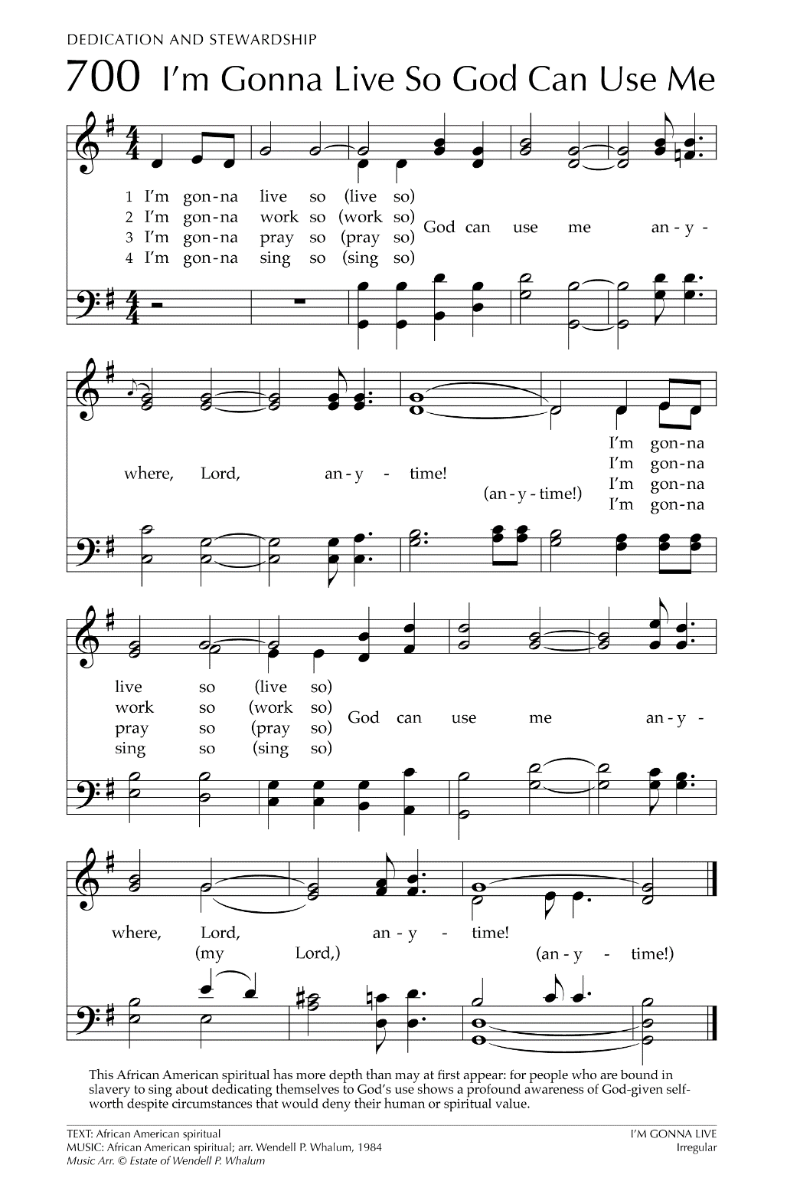

THE WORD
PRAYER OF ILLUMINATION
SCRIPTURE
Psalter Psalm 78: 1-7
Newer Testament Matthew 25:1-13
This is the Word of the Lord.
Thanks be to God.
SERMON “Change Happens”
OUR RESPONSE
*AFFIRMATION OF FAITH: As one people, with one voice, we affirm our faith in God, Creator and Sustainer of all that is. From frozen arctic ice caps to flowering desert cacti, from microbes and quarks to vast galaxies, God intricately knit our universe together. The laws of physics and mathematics, the multiplicity of languages and cultures, the precision of our bodies, the wealth of wisdom from poets, philosophers, artists and dreamers speak to the awesome power, incomparable intelligence and the unfathomable mystery of God. This is the God who loves us. This is the God we were made to enjoy. This is the God we serve. All glory and praise to God!
THE OFFERING

CALL FOR OFFERING Matt 25
We need oil for our lamps, food for our tables, and love for our lives.
Let us share the bounty we have received, that no one may be left out alone in the dark.
OFFERTORY ANTHEM
*DOXOLOGY #607

PRAYER OF DEDICATION Josh 24
We come before you, O God, with gifts in your name in service of the world. We bring you this offering, as a symbol of our choice to follow you. Receive these gifts of love, that they may go forth as your blessing and wisdom for the world. Amen.

THE SENDING
CLOSING HYMN O Beautiful for Spacious Skies #338 CHARGE AND BENEDICTION
RESPONSE (sung in unison) Three Fold Amen

